EMPLOYEE TRACKER
@CREATIVITY THINK (9483175986/7019689991)

ABSTRACT:
Employee Tracker is a dashboard web application designed to assist HR teams and company administrators in managing employee information, attendance, leave, wages, and performance analytics. The platform provides a centralized system where employees can view their profiles, log activities, mark attendance, request leave, and access wage reports. Administrators can add and manage employee records, monitor attendance, approve leave requests, and generate analytics reports for better workforce management. Developed using Django and Django REST Framework for backend processes, and React with Axios and Recharts for frontend interaction, the system offers a scalable, efficient, and secure solution for modern employee management..

INTRODUCTION OF THE PROJECT:
In organizations, managing employee data, attendance, and payroll can be complex and error-prone if handled manually. Traditional spreadsheets and paper records fail to provide real-time updates, analytical insights, and operational efficiency. Employee Tracker addresses these challenges by providing a centralized digital platform for recording, monitoring, and analyzing employee activities, attendance, leave, and wages. With role-specific dashboards, secure APIs, and interactive visualization, the system enhances HR efficiency and employee accountability while providing accurate performance data for decision-making..

PROJECT OBJECTIVES:

• Provide a centralized dashboard for employee information management.
• Allow employees to log activities, mark attendance, and request leaves.
• Track and calculate wage reports based on attendance and leaves.
• Enable administrators to add, edit, and manage employee records.
• Monitor attendance logs, leave requests, and employee performance.
• Generate analytics reports with visual charts for HR decision-making.
• Ensure secure, reliable, and scalable backend APIs.
• Streamline HR operations and improve workforce management efficiency.

PROBLEM OF THE STATEMENT:
Companies often struggle with maintaining accurate employee records, tracking attendance, and monitoring leave or wage data. Manual processes lead to errors, inefficiencies, and delayed reporting. Managers and HR teams lack actionable insights into employee performance, attendance patterns, and payroll calculations. Employee Tracker solves these problems by providing a structured, digital platform that automates attendance, leave management, wage calculation, and analytics while keeping employee data secure and easily accessible..

MOTIVATION OF THE PROJECT:
• To simplify HR operations through digital management tools.
• To improve transparency and accuracy in attendance and wage reporting.
• To allow employees easy access to personal records and leave requests.
• To enable administrators to monitor and manage workforce performance efficiently.
• To provide visual insights into employee activity and operational trends.
• To ensure data security and auditability in HR processes.

BLOCK DAIGRAM OF PROJECT:

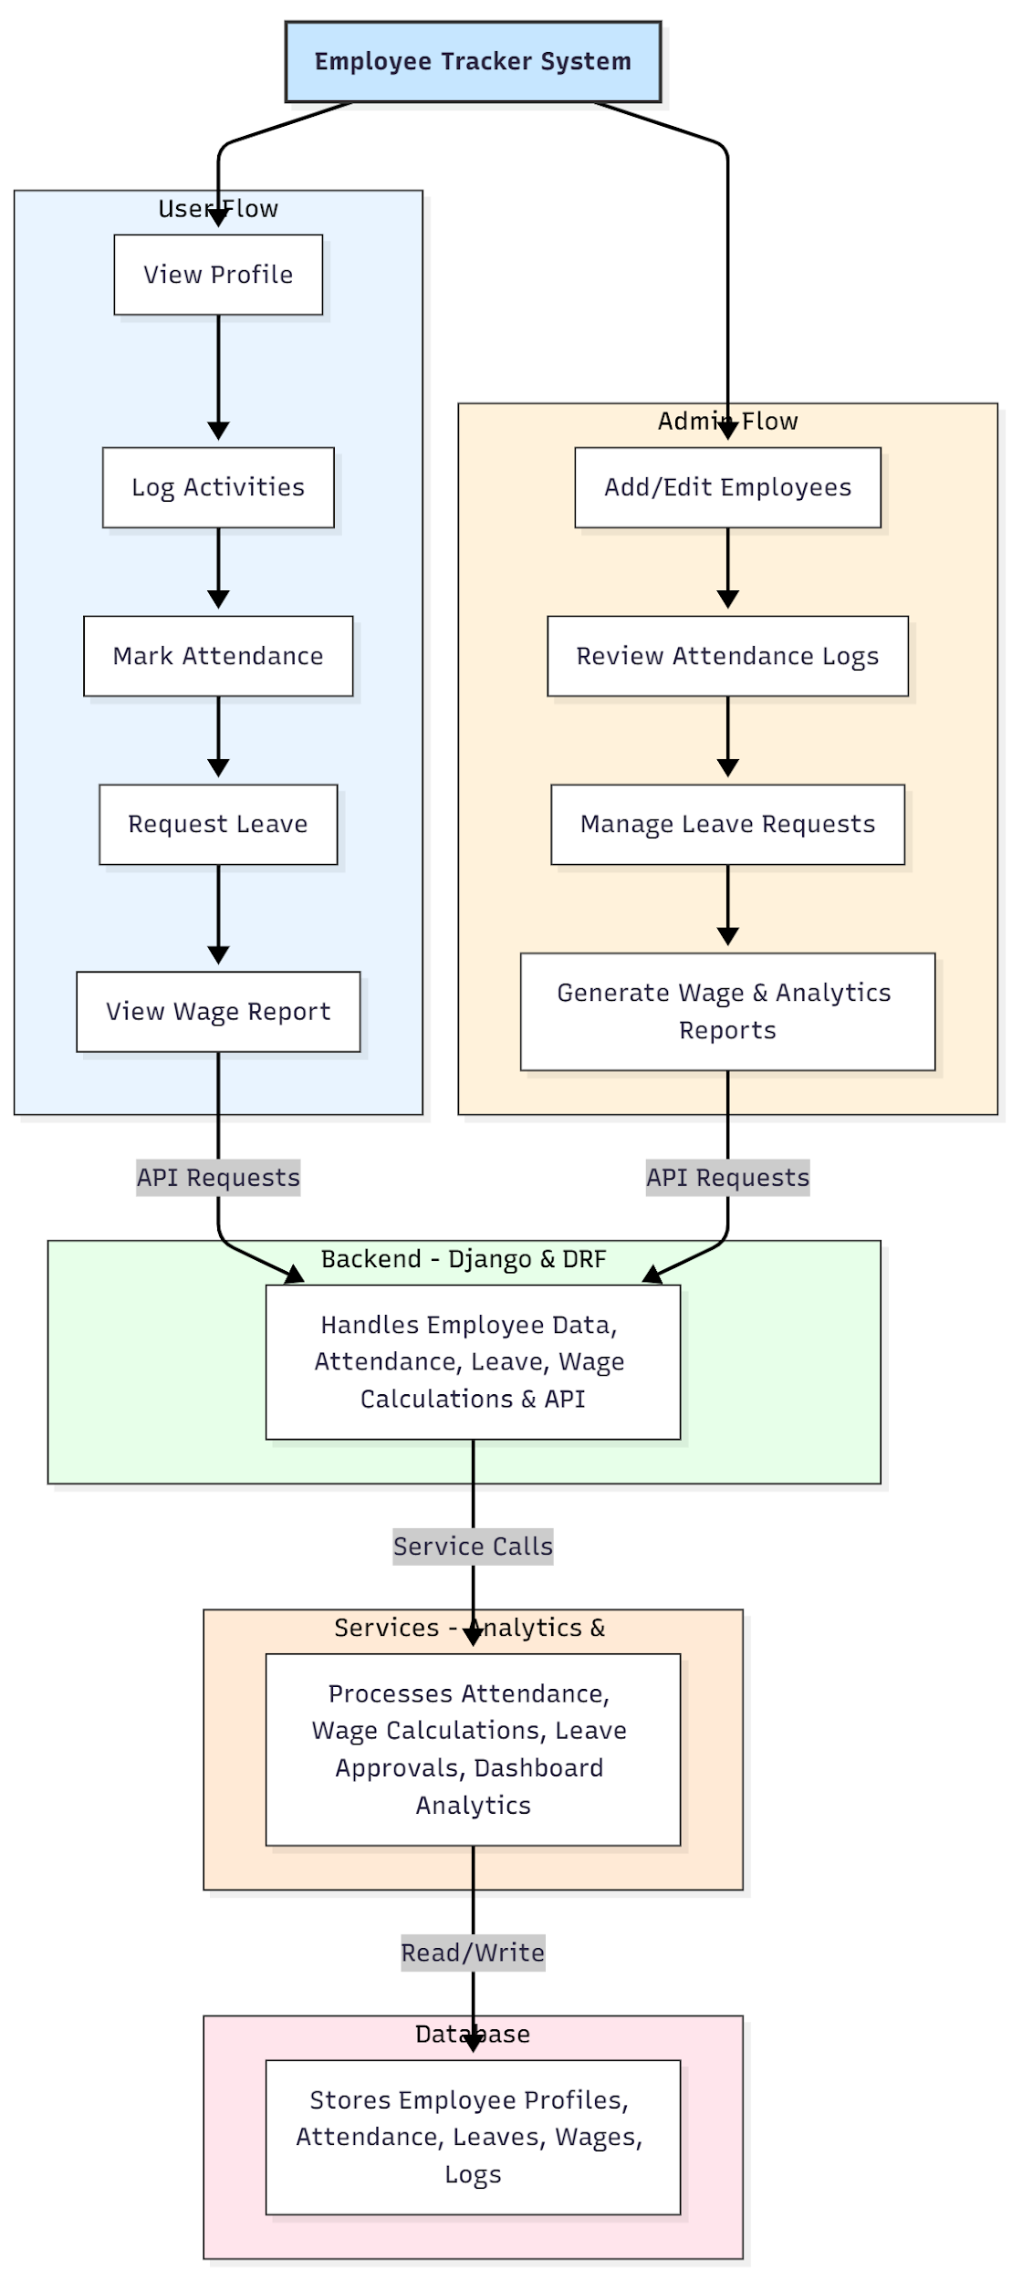

WORKING OF THE PROJECT:
Employees log in to the system and can view their profile details, record daily activities, mark attendance, and request leave. The backend validates and stores all actions in the database. Wage calculations are updated automatically based on attendance and leave records. Administrators can add or edit employee profiles, review attendance logs, manage leave requests, and generate analytics reports through dashboards. The services module processes calculations, approves requests, and visualizes performance metrics. The database ensures secure storage and easy retrieval of all employee data, allowing a streamlined workflow for both users and HR administrators..

SOFTWARE REQUIREMENT:
- Backend:
  - Python 3.x
  - Django
  - Django REST Framework
  - SQLite/PostgreSQL
- Frontend:
  - Node.js and npm
  - React.js
  - Axios
- Development Tools:
  - Visual Studio Code
  - Postman (for testing APIs)
  - Git/GitHub (for version control)
- Server/Deployment (Optional):
  - Gunicorn, Nginx, or Heroku/AWS for hosting

ADVANTAGES OF THE PROJECT:

• Centralized management of employee profiles, attendance, and wages.
• Automated tracking of attendance and leave requests.
• Real-time wage and activity calculations.
• Interactive analytics dashboards for HR insights.
• Reduces manual errors and administrative workload.
• Secure and role-based access to sensitive employee data.
• Improves transparency and accountability in workforce management.
• Scalable system suitable for small to medium-sized organizations.

APPLICATIONS OF THE PROJECT:
• HR departments in organizations
• Staffing and recruitment agencies
• Companies requiring performance monitoring
• Payroll and wage management solutions
• Attendance tracking for educational institutions or offices
• Employee performance analytics

REFERENCES:

- Django REST Framework Documentation — Django Software Foundation. Django Documentation. Available: https://docs.djangoproject.com/
- Django REST Framework. DRF Documentation. Available: https://www.django-rest-framework.org/
- React. React Official Documentation. Available: https://reactjs.org/docs/getting-started.html
- Redux. Redux Documentation. Available: https://redux.js.org/introduction/getting-started
- PostgreSQL Global Development Group. PostgreSQL Documentation. Available: https://www.postgresql.org/docs/
- MySQL. MySQL Reference Manual. Available: https://dev.mysql.com/doc/
- Git. Git Documentation. Available: https://git-scm.com/doc
- Node.js. Node.js Documentation. Available: https://nodejs.org/en/docs/
- Axios. Axios Documentation. Available: https://axios-http.com/docs/intro
- Socket.io Documentation – https://socket.io/docs/

